INVESTIGATING ARCHIMEDES’ PRINCIPLE
Skill: AI
AIM: To investigate the displacement of water and apparent loss of weight when an object is immersed in water.
APPARATUS and MATERIALS:

- Electronic balance
- Newton meter/ spring balance
- Wooden block
- Objects to be investigated – Styrofoam ball, rubber ball
- Beaker
- Displacement can
- String
- plasticine

DIAGRAM:
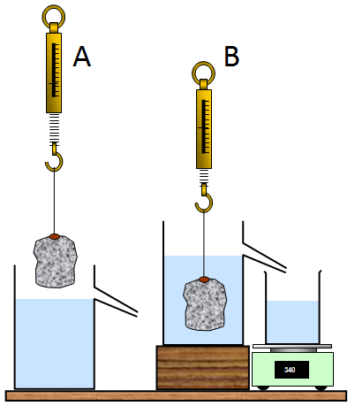
Drawing showing set up of displacement can, newton meter and scale.

INSTRUCTIONS:
- Assemble the apparatus as in the diagram above. Ensure the water in the displacement can is exactly level with the spout.
- Measure and record the weights (in Newtons) of the objects being investigated and the weight of the empty beaker.
- Lower the object so that it is fully immersed in the water as shown in diagram B.
- Allow all the water to finish running out of the displacement can, then note the apparent weight of the object (on the newton meter) and the weight of the beaker+water displaced.
- Repeat steps 3 and 4 for the other objects.
- Record all values in a table.
- Discuss the findings with respect to apparent loss of weight of the object and gain in weight of the beaker.

Rewrite your method into past tense in the space below or on a separate page.

RESULTS:
Table showing
1 | 2 | 3 | 4 | 5 | 6 | 7
Object | Weight in air (N) | Apparent weight in water (N) – on spring balance | Apparent loss in weight by object (N)  (2) - (3) | Weight of empty beaker (N) | Weight of beaker and water (N) | Gain in weight (N)  (6) – (5)
100g
200g
500g

W | = | m x a
Weight  (N) | = | mass x  (kg) | acceleration due to gravity (10)  (m/s² )

Calculations:
1. Mass (g) to mass in (kg) –
if 1000g = 1kg,
then 100g = (1/1000) x 100
= 0.1 kg

2. Mass (kg) to Weight (N) –
since W = m x a
W= 0.1 kg x 10
= 1 N

DISCUSSION: Write your responses in full prose on a separate page – use paragraphs
- What is a fluid?
- Why do objects move through a fluid?
- State Archimedes’ principle.
- Give an application of its usefulness to real life.

- What did you notice about the weights recorded, especially in columns 4 and 7 of your table?
- What was the manipulated variable in this experiment?
- What was the responding variable in this experiment?

- What determines the apparent loss of weight in the water?
- Complete this sentence:
The apparent loss in w________ by an object when it is immersed in w__________ is called the upthrust. The u_________ is equal to the w__________ in water that is d______________. This is Archimedes’ principle.

CONCLUSION: What did you find out in this experiment.
According to the results of the experiment, when an object is placed in a fluid, a force called ___________ acts on it and displaces the weight of fluid equal to the w ________ of the object

MARKSCHEME – ANALYSIS AND INTERPRETATION (AI)
Criteria | Marks
- Calculating weight of objects correctly in Newtons – Table column 2 | 1
- Calculating column 4 and 7 in the table correctly | 1
- What is a fluid? | 1
- Stating Archimedes’ principle | 1
- Usefulness of Archimedes’ principle in real life | 1
- Linking the values in column 4 with that in column 7 | 1
- Identifying the manipulated and responding variables correctly | 1
- Stating upthrust force causes the apparent loss of weight in the water | 1
- Conclusion – related to the aim of the experiment and states the results | 2
TOTAL | 10

