INVESTIGATING RUSTING
Skills: AI, ORR
AIM: To investigate the conditions which affect rusting
APPARATUS and MATERIALS:

- 6 test tubes
- 2 stoppers/covers
- 6 new iron nails
- Sand paper
- dropper
- Distilled water
- Salt water
- Boiled and cooled water
- Sulphuric acid
- 25ml measuring cylinder
- Anhydrous calcium chloride (CaCl)
- Oil
- labels

DIAGRAM:
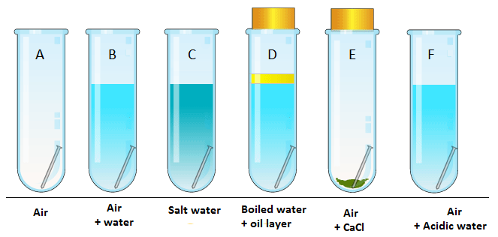
Diagram showing set up of apparatus to investigate conditions for rusting.

INSTRUCTIONS:
- Label 6 test tubes A, B, C, D, E, and F respectively
- Place one nail in each tube as indicated in the diagram above. Ensure that the nails are new and not tarnished (showing any signs of rusting); use the sandpaper if necessary.
- Create the required conditions in each tube by adding the appropriate solutions
- Ensure for test tube D – the water is not shaken before pouring into the tube and the oil completely covers the water before placing the bung/ stopper..
- Record the appearance of the nails initially and after 1, 3, 7 and 8 days in an appropriate table.

Rewrite your method into past tense in the space below or on a separate page.
METHOD:
______________________________________________________________________________________________________________________________________________________________________________________________________________________________________________________________________________________________________________________________________________________________________________________________________________________________________________________________________________________________________________________________________________________________________________________________________________________________________________________________________________________________________________________________________________________________________________________________________________________________________________________________________________________________________________________________________________________________________________________________________________________________________________________________________________________________________________________________________________________________________________________________________________________________________________________________________________________________________________________________________________________________________________________________________________________________________________________________________________________________________________________________________________________________________________________________________________________
RESULTS:
Table showing _________________________________________________________________

Tube | Contents/ conditions | Appearance of the nail/ tube
 |  | Initial - Day 0 | Day 3 | Day 7 | Day 8
A
B
C
D
E
F

DISCUSSION: Write your responses in full sentences on a separate page – use paragraphs.
- What is rusting? Write a general equation to show this.
- From your results, which nails became the most rusty? Why is that so?
- From your results, what conditions are necessary for rusting? (Hint: Air/ water/ salt/ acid?
- Is the rusting the same in tap water (tube B) and distilled water (tube D)?
- Does salt speed up the rate of rusting?
- Why did the rust flakes sink to the bottom of the test tube?

- What precautions did you take when setting up the apparatus? And why?(Hint – 1. use new nails/ untarnished nails, 2. ensure you did not cross contaminate solutions, for test tube

- Why should iron and steel objects near the coastline be kept dry?
- Why is iron not used for storing pickled food materials? (Hint, pickled foods contain acids.)
- How can rusting of iron/ metal surfaces be prevented?

CONCLUSION: What did you find out in this experiment?
According to the results of the experiment, rusting is caused by the presence of the following conditions - ____________________________ and speeded up by _____________________. Rusting can be prevented by ___________________________________________________.

MARKSCHEMES
ANALYSIS AND INTERPRETATION (AI)
Criteria (AI) | Marks
- What is rusting | 2
- General equation for rusting | 2
- General statement about rusting – caused by | 2
- Why rust flakes sink to bottom of tube | 2
- Conclusion | 2
TOTAL | 10

OBSERVE, RECORD & REPORT (ORR)
Criteria (ORR) | Marks
- Method in past tense | 1
- Title of table | 1
- Results in table for each tube all completed | 6
- Discussion complete | 1
- Correct format of lab | 1
TOTAL | 10

RUSTING – the process of forming RUST (iron III oxide)
- Iron is tarnished by forming rust, a form of hydrated iron oxide.
- Word equation: Iron + oxygen (in presence of moisture) Rust
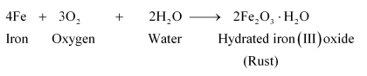
- Rust does not protect the surface of the metal, in fact it becomes crumbly and flakes off to expose fresh iron to attack.
- Rust weighs more than the original iron.
- For rusting to take place iron (or steel) must be in contact with air (oxygen) and water.
- The presence of salt (sodium chloride) for example in sea spray can speed up the process of rusting.
- Areas with lots of water vapour or acidic gases can also speed up rusting.

PREVENTING RUSTING
- Iron can be protected against rusting by coating it usually with paint, zinc (galvanising), electroplating with tin (found in food cans) and plastic coating. This stops air and water from getting to the iron.
- Oiling your iron and steel tools also prevents rusting.
- Mixing nickel and chromium to molten steel forms the rust-proof allow stainless steel.
