INVESTIGATING COMMON CHEMICALS USING UNIVERSAL INDICATOR
Skills: AI
AIM: To identify common (household) chemicals as an acid or base using universal indicator
APPARATUS and MATERIALS:

- Smaller beakers labelled with each chemical
- Droppers for each chemical
- Universal indicator paper strips
- Chart for universal indicator paper
- Household chemicals – lemon juice, baking soda, toothpaste
- Washing soda (NaCO₃), salt, coca cola, distilled water, limewater

DIAGRAM:

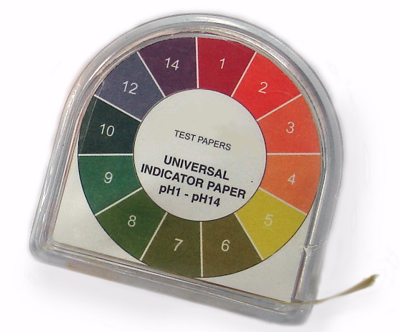
Diagram showing colours of universal indicator paper with various pH values.

INSTRUCTIONS:
- Measure out 5ml of each chemical and place in labelled beakers.
- Using a dropper add one or two drops of solution onto the universal indicator paper.
- Note the colour that it becomes and record it in the table.
- Decide if that chemical is an acid, an alkali or neutral in pH.

Rewrite your method into past tense in the space below or on a separate page.
METHOD:
______________________________________________________________________________________________________________________________________________________________________________________________________________________________________________________________________________________________________________________________________________________________________________________________________________________________________________________________________________________________________________________________________________________________________________________________________________________________________________________________________________________________________________________________________________________________________________________________________________________________________________________________________________________________________________________________________________________________________________________________________________________________________________________________________________________________________________________________________________________________________________________________________________________________________________________________________________________________________________________________________________________________________________________________________________________________________________________________________________________________________________________________________________________________________________________________________________________
RESULTS:
Table showing _________________________________________________________________

Name of Substance | Chemical name | Indicator Colour | pH number
Lemon juice | Citric acid
Baking soda | Sodium hydrogen-carbonate
Toothpaste | Mixture
Washing soda | Sodium carbonate
Salt | Sodium chloride
Coca Cola | Mixture
Distilled water | Hydrogen oxide
Limewater | Calcium hydroxide

DISCUSSION: Write your responses in full sentences on a separate page – use paragraphs.
- Define the terms – acid and base or alkali.
- Neutral solutions have what pH value?
- Which solutions tested were acids and which were alkaline or bases?
- Why does lemonade/ lime juice have a sharp taste?
- Are acids and bases useful in our everyday lives? How?
- Draw a pH scale like the one below and fill it in.

 | pH value | Colour | Examples
Strong acids | 0 | Deep red
 | 1 | Red
 | 2
 | 3
Weak acid | 4 | Orange
 | 5 | yellow
Slightly acidic | 6
Neutral | 7 | Green
Slightly alkaline | 8 | Dark green
Weak alkali | 9
 | 10 | Light blue
 | 11
Strong alkali | 12 | Violet – purple
 | 13
 | 14

CONCLUSION: State what you found out in this experiment?

MARKSCHEME - ANALYSIS AND INTERPRETATION (AI)
Criteria (AI) | Marks
- What is an acid? | 2
- What is a base or alkali? | 2
- How can an acid be neutralized? | 2
- How are acids and bases useful in our everyday lives? | 2
- Conclusion | 2
TOTAL | 10

