INVESTIGATING OHM’S LAW IN A SERIES CIRCUIT
Skills: AI & ORR
AIM: To calculate resistance in a series circuit.
APPARATUS and MATERIALS:

DIAGRAM:

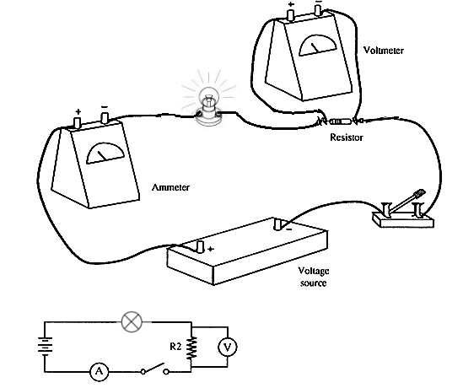

Diagram showing how to set up the ammeter and voltmeter across the resistor.

INSTRUCTIONS:
- Set up a series circuit using the bulb, cell and ammeter.
- Place a resistor in series between the bulb and the ammeter.
- Add the voltmeter parallel to the resistor.
- Record the readings on the ammeter and the voltmeter when the switch is closed or the circuit is complete.
- Change the resistor and again record the current on the ammeter and the voltage.
- Calculate the resistance for each resistor using the formula V= I x R and solving for R.
Rewrite your method into past tense in the space below or on a separate page.
METHOD:
______________________________________________________________________________________________________________________________________________________________________________________________________________________________________________________________________________________________________________________________________________________________________________________________________________________________________________________________________________________________________________________________________________________________________________________________________________________________________________________________________________________________________________________________________________________________________________________________________________________________________________________________________________________________________________________________________________________________________________________________________________________________________________________________________________________________________________________________________________________________________________________________________________________________________________________________________________________________________________________________________________________________________________________________________________________________________________________________________________________________________________________________________________________________________________________________________________________
RESULTS: Draw a table in the space provided to collect your results.
Table showing______________________________________________________________.

Calculations: _______________________________________________________________
__________________________________________________________________________
__________________________________________________________________________
__________________________________________________________________________

Draw and label how the circuit was set up in the experiment using a circuit diagram and symbols.

TITLE: _______________________________________________________________________
DISCUSSION: Write your responses in full sentences on a separate page – use paragraphs.
- What is amps? And what instrument measures it?
- What is voltage? And what instrument measures it?
- How is the ammeter and voltmeter supposed to be connected in relation to a resistor in a circuit.
- What is resistance?
- What relationship did you observe between current and voltage as the resistor changed/ increased?
- State Ohm’s law as it relates to resistance. – The current flowing through a metal is ___________________ to the potential difference (voltage) across it.

CONCLUSION: State what you found out in this experiment?
The larger a resistor causes an ….

_______________________________________________________________________
MARKSCHEMES –

ANALYSIS AND INTERPRETATION (AI)
Criteria (AI) | Marks
- Explaining amps and ammeter | 2
- Explaining volts and voltmeter | 2
- Stating the relationship based on results shown | 2
- Explaining Ohm’s law. | 2
- Conclusion | 2
TOTAL | 10

ORR CRITERIA |  | Mark
Observations  (accurate) | Significant changes noted - bulb  Figures correct – V & A  Circuit Diagram | 3
Recording  Tables | Title – above, in capitals - 1  Column & row headings (with units) - 1  Enclosed and neat -1 | 3
Reporting | Format - all sections present – 1  All apparatus correct  Acceptable language and expression –  grammar – 1 and spelling – 1 | 4

