CHROMATOGRAPHY
Skills: ORR
AIM: To separate the colours in a drop of green ink.
APPARATUS and MATERIALS:

- Green ink
- Dropper
- Beaker (100ml)
- Water
- Chromatography paper
- Or filter paper strip
- Ruler
- Pencil

DIAGRAM:

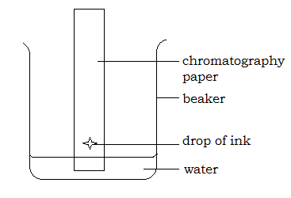

Diagram showing how to set up the chromatography paper and water in the beaker.

INSTRUCTIONS:
- Use a ruler and measure a distance 4cm away from the short edge of the chromatography paper. Place a cross here using a pencil.
- Add water to the beaker to a depth of only 2cm
- Using the dropper carefully place one drop of green ink onto the cross on the chromatography paper.
- Ensure the drop does not run down. Place the paper into the beaker.
- Ensure the drop of ink is not below the water level.
- Allow ten minutes to pass, and observe and record what has happened to the drop of ink and the colours on the chromatography paper. Stick your dried paper in your results.
Rewrite your method into past tense in the space below or on a separate page.
METHOD:
____________________________________________________________________________________________________________________________________________________________________________________________________________________________________________________________________________________________________________________________________________________________________________________________________________________________________________________________________________________________________________________________________________________________________________________________________________________________________________________________________________________________________________________________________________________________________________________________________________________________________________________________________________________________________________________________________________________________________________________________________________________________________________________________________________________________________________________________________________________________________________________________________________________________________________________________________________________________________________________________________________________________________________
RESULTS:
Stick your strip of chromatography paper after it has dried completely.

Describe in words what happened. Indicate which colours are furthest away from the original drop and which colours are inbetween.

______________________________________________________________________________________________________________________________________________________________________________________________________________________________________________________________________________________________________________________________________________________________________________________________________________________________________________________________________________________________________________________________________________________________________________________________________________________________________________

DISCUSSION: Write your responses in full sentences on a separate page – use paragraphs.
- What is chromatography?
- How is chromatography useful in real life?

- Explain two precautionary measures you took when carrying out this experiment.
- What was the solvent used in this experiment?
- Are there other solvents, name two and the solutes they dissolve.

CONCLUSION: State what you found out in this experiment?

_______________________________________________________________________
MARKSCHEMES –
ORR CRITERIA |  | Mark
Observations  (accurate) | Significant changes noted  Original and final conditions compared  Control noted OR diagram | 3
Recording | Title of paper stuck  Recording all the colours seen  Indicating time taken. | 3
Reporting | Format - all sections present – 1  Aim in capital letters - 1  Acceptable language and expression –  grammar – 1 and spelling – 1 | 4

