MOMENTS – THE TURNING EFFECT OF A FORCE
Skills: ORR
AIM: To investigate the turning effect of a force using levers.
APPARATUS and MATERIALS:

- A meter rule with hole at 50cm
- Masses – 3-4 different pieces (10g, 20g, 50g, 100g)
- Pieces of yarn/string
- Modelling clay
- Metal hooks (4-5)
- scissors
- retort stand and clamp

DIAGRAM:

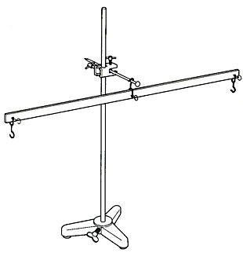

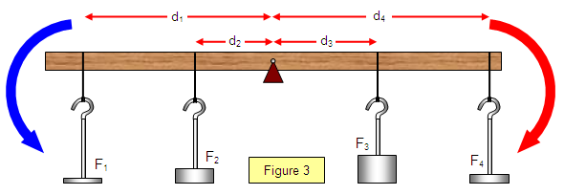
Diagram showing how to set up ruler on the retort stand to investigate moments.

INSTRUCTIONS:
- Tie the string through the central hole of the ruler and suspend it from a clamp on the retort stand.
- Use a piece of modelling clay to balance the ruler as necessary.
- Hang a 20g mass (which exerts a force of 0.2N) on the left side of the ruler at 10cm (0.1m) from the fulcrum.
- Add another 10g mass (force 0.1N) to the ruler at a point that will allow the ruler to balance again.
- Take the masses off, and try other ones at different distances from the fulcrum. In each case you must make the ruler balance.
- Record your results (masses and distances) in the table and calculate the moments.

Rewrite your method into past tense in the space below or on a separate page.
METHOD:
____________________________________________________________________________________________________________________________________________________________________________________________________________________________________________________________________________________________________________________________________________________________________________________________________________________________________________________________________________________________________________________________________________________________________________________________________________________________________________________________________________________________________________________________________________________________________________________________________________________________________________________________________________________________________________________________________________________________________________________________________________________________________________________________________________________________________________________________________________________________________________________________________________________________________________________________________________________________________________________________________________________________________________
RESULTS:
Table showing _______________________________________________________________
Left side |  |  | Right side
Force f1  (newtons) | Distance – d1  (meters) | Moment  f1 x d1 | Force f2  (newtons) | Distance – d2  (meters) | Moment  F2 x d2
0.4 N | 0.1m | 0.4N x 0.1m = 0.04Nm | 0.1N | 0.4m | 0.1N x 0.4m = 0.04Nm
Note the units in the table are Newtons and meters; your masses are in grams and centimeters. You must convert them.

Calculations:
Force due to gravity that pulls a mass of 1kg is approximately 10N.
So 1000g exerts 10N of force
So 1g = 10/1000 = 0.01N
Therefore the force exerted by a 40g mass = 0.4N
Sample calculations:
______________________________________________________________________________
______________________________________________________________________________
______________________________________________________________________________
______________________________________________________________________________
______________________________________________________________________________
______________________________________________________________________________

DISCUSSION: Write your responses in full sentences on a separate page – use paragraphs.
- What is a moment of a force?
- What relationship can you determine from your table of results?
- Can a lighter mass (force) be used to move a heavier mass (force)?
- How or when will the moment of a force be useful to you in real life?
________________________________________________________________________________________________________________________________________________________________________________________________________________________________________________________________________________________________________________________________________________________________________________________________________________________________________________________________________________________________________________________________________________________________________________________________________________________________________________________________________________________________________________________________________________________________________________________________________________________________________________________________________________________________________________________________________________________________________
CONCLUSION: State what you found out in this experiment?
____________________________________________________________________________________________________________________________________________________________
MARKSCHEMES –
ORR CRITERIA |  | Mark
Observations  (accurate) | Significant changes noted  Original and final conditions compared  Control noted OR diagram | 3
Recording  Tables | Title – above, in capitals - 1  Column & row headings (with units) - 1  Enclosed and neat -1 | 3
Reporting | Format - all sections present – 1  Aim present - 1  Acceptable language and expression –  grammar – 1 and spelling – 1 | 4

