INVESTIGATING OSMOSIS USING POTATO STRIPS
AIM: To investigate osmosis using potato strips, and salt water. Skill: ORR
APPARATUS and MATERIALS:

- Potato
- Cork borer
- 2 Petri dishes
- Distilled water
- Salt water
- Ruler
- Forceps
- Knife
- White tile
- Measuring cylinder
- Paper towel
- labels

DIAGRAM:
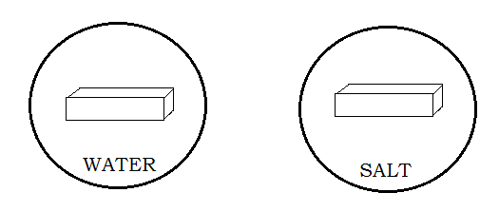
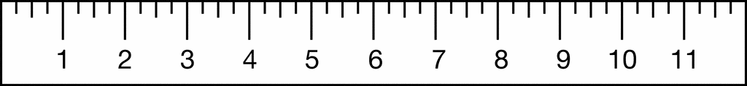
DIAGRAM SHOWING THE SET UP OF APPARATUS TO INVESTIGATE OSMOSIS.
METHOD:
- Cut two potato strips to the same size (1cm x 1cm x 5cm). Dry them on a paper towel.
- Label one Petri dish ‘water’ and the other one ‘salt solution’. Measure out 30ml of each liquid and put in the appropriate petri dish.
- Note the initial textures of each strip then, add one potato strip to each dish.
- Every 5 minutes, take out the strips, dry them and measure the length to the nearest mm. Record the lengths in the table, along with the final texture of the strips.
- Use a graph paper to make a line graph of the change in lengths of the potato strips.

RESULTS: (Add a title to the table and collect your measurements, then plot a graph.)

Table showing _________________________________________________________________
Time (mins) | Length of strip in  water (cm) | Texture of strip in water | Length of strip in  Salt solution (cm) | Texture of strip in salt solution
0
5
10
15
20

Graph - Plot on a separate graph page or below.
Remember to put a TITLE and scale, label the axes with units of time (mins) or size (mm).

DISCUSSION: (On a new page, using paragraphs)
- Define osmosis.
- State what happens to plant cells when placed in pure water (high water concentration) as opposed to when placed in salt solution (low water concentration).
- Will plant cells burst when placed in pure water? Why or why not?

- What do your results (from the graph) show? What is the trend?
- Is there any precautions you took before measuring the strips?
- Is there any way to improve the results? (Hint – using change in mass instead; or using more than one potato strip and finding average lengths.)

CONCLUSION: (Relate to your aim. What did you find out in this lab about osmosis/ putting plant cells into pure water or salt water?)

MARKSCHEME – OBSERVING, RECORDING AND REPORTING SKILLS (ORR)
ORR CRITERIA |  | Max Mark | Teacher  Mark
Observations  (accurate) | - Significant changes noted  - Original and final conditions compared  - Control noted OR diagram | 3
Recording  Tables/ Graph | - Title – above, in capitals - 1  - Column & row headings (with units) - 1  - Enclosed and neat -1  OR  - Title – at base, in capitals, underlined -1  - Both axes labelled with units - 1  - Accurate plots – 1 | 3
Reporting | - Format - ALL sections present – 1  - Aim in capital letters - 1  - Acceptable language and expression –  grammar – 1 and spelling – 1 | 4
TOTAL |  | 10

