FOOD TESTS – CARBOHYDRATES (SUGARS AND STARCH)
AIM: To identify reducing sugars, non-reducing sugars and starch in pure form and lunch sample. Skill: ORR/MM
APPARATUS and MATERIALS:

- 6 Test tubes
- Test tube holder
- Test tube rack
- Large beaker
- Bunsen Burner
- Glass rod/stirrer
- 2 syringes
- Benedict’s solution
- Dilute hydrochloric acid (HCl)
- Sodium hydroxide (NaOH)
- Iodine solution
- Distilled water
- Glucose solution
- Sucrose solution
- Starch solution
- Sample of lunch – rice/ bread/chicken
- Labels

DIAGRAM:
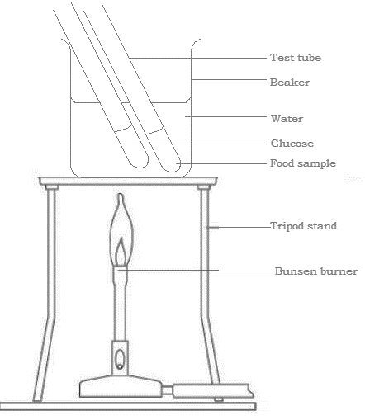
DIAGRAM SHOWING THE SET UP OF WATER BATH FOR REDUCING SUGAR TESTS.
METHOD:
Benedict’s Test (Reducing sugar test):
- Label 2 test tubes – glucose and food sample.
- Add 2cm³ of Benedict’s solution to 1cm³ of the glucose solution in the test tube labelled glucose
- Place the test tube in a beaker of boiling water for about 2 minutes.
- Observe and record the colours of the solution at the start and after the 2 minutes.
- Repeat step 2- 4 using food sample crushed in water instead of the glucose solution.
Non-reducing sugar test:
- Label 2 clean test tubes – sucrose and food sample.
- Add 1cm³ of dilute HCl to 1cm3 of sucrose solution in the test tube labelled sucrose.
- Place the test tube into the water bath for 2 minutes. Then remove and cool.
- Add sodium hydroxide (NaOH) until the fizzing stops. (to neutralize any acid)
- Add 2cm³ of Benedict’s solution and then place the test tube into the water bath for 2 minutes.
- Observe and record the colours of the solution at the start and after the 2 minutes.
- Repeat steps 2 – 6 using the food sample crushed in water instead of the sucrose.
Starch test (Iodine test)
- Label 2 clean test tubes – starch and food sample.
- Place 2cm³ of starch solution to the test tube labelled starch.
- Add 2 drops of iodine solution to the starch solution, observe and record the colours.
- Repeat steps 2-3 using food sample (either solid or liquid) instead of the starch solution.
Rewrite your method into past tense in the space below or on a separate page.
METHOD:
______________________________________________________________________________________________________________________________________________________________________________________________________________________________________________________________________________________________________________________________________________________________________________________________________________________________________________________________________________________________________________________________________________________________________________________________________________________________________________________________________________________________________________________________
RESULTS: (Add a title to the table and record your colour observations for each food test.)

Table showing _________________________________________________________________
TEST | CONTENTS OF TEST TUBE | OBSERVATIONS  (ORIGINAL AND FINAL) | INFERENCE
BENEDICT’S TEST (REDUCING SUGAR)
NON-REDUCING SUGAR TEST
STARCH TEST
NOTE: An inference is a statement saying if the food substance (reducing sugar/ starch) is present or if the food substance is absent. OR that the observation is the positive for reducing sugar/ non-reducing sugar/ starch.

DISCUSSION: (On a new page, using full sentences in paragraphs)
- What are food tests used to identify?
- Name the reagents that are used to identify reducing sugars and starch.
- Why is there a need for acid hydrolysis of sucrose before the Benedict’s test is conducted (Hint: sucrose is a disaccharide).

- From your results what are the positive colour results that identify reducing sugars, non-reducing sugars and starch.
- Based on your results what biomolecules/ food groups is present in the food sample tested?

- What precautions did you take in conducting your experiment?
(Hint: Use a clean test tube and syringes for each test; do not cross contaminate food samples and pure form solutions. Make sure to neutralize the acid properly for the non-reducing sugar test. )
CONCLUSION: (ON A NEW PAGE - Relate to your aim and findings/results.)
See a sample below:
In pure form, reducing and non-reducing sugars cause Benedict’s solution to _________________________________________________________________; while starch causes iodine solution to _______________________________. Food sample ______________ contained _____________________________________________________, as observed by the positive colour results.

MARKSCHEME – OBSERVING, RECORDING AND REPORTING ( ORR ) CRITERIA |  | Mk
Observations | - Significant changes noted  - Original and final conditions compared  - Control noted OR diagram | 3
Recording  Tables/ Graph | - Title – above, in capitals - 1  - Column & row headings (with units) - 1  - Enclosed and neat -1  OR  - Title – at base, in capitals, underlined -1  - Both axes labelled with units - 1  - Accurate plots – 1 | 3
Reporting | - Format - ALL sections present – 1  - Aim in capital letters - 1  - Acceptable language and expression –  grammar – 1 and spelling – 1 | 4
TOTAL |  | 10

MARKSCHEME – MANIPULATION AND MEASUREMENT ( MM ) CRITERIA |  | Mks
Assembly of water bath | - Position tripod over bunsen  - Position gauze on tripod  - Correct placement of Bunsen and tripod in centre of desk | 3
Beaker | - Select appropriate size beaker  - 2/3 fill beaker with water  - Place carefully on centre of gauze on tripod | 3
Bunsen Burner | - Slide Bunsen burner out  - Light Bunsen – turning on gas first  - Adjust flame on Bunsen under tripod | 4
TOTAL |  | 10

