FOOD TESTS – PROTEINS AND LIPIDS (FATS)
AIM: To identify proteins and lipids in pure form and lunch sample. Skill: ORR/MM
APPARATUS and MATERIALS:

- 6 Test tubes
- Test tube holder
- Test tube rack
- Glass rod/stirrer
- Droppers
- Cork/ stopper
- alcohol
- Sodium hydroxide solution (NaOH)
- 5% copper sulphate solution (CuSO₄)
- Distilled water
- Proteins solution
- Sample of lunch – rice/ bread/chicken
- Labels

DIAGRAM:
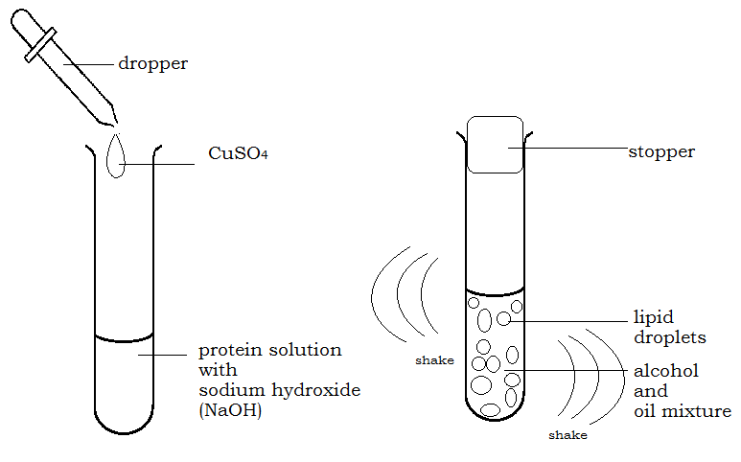
DIAGRAM SHOWING THE SET UP FOR PROTEIN AND LIPIDS TESTS.
METHOD:
Protein test:
- Label 2 test tubes protein and food sample.
- Put 2cm³ of protein solution in a test tube labelled protein
- Add the same amount of dilute sodium hydroxide (NaOH) followed by 4 drops of 5% Copper Sulphate solution. Shake gently
- Observe and record the colour of the solution before and after.
- Repeat these steps for the food sample instead of the proteins solution.
Lipid (Emulsion) test:
- Label 2 clean test tubes – lipid and food sample.
- Add 1cm³ oil to 2cm³ of alcohol in a test tube
- Put a cork over the top of the test tube and shake it thoroughly
- Add the mixture to a test tube with 2cm³ of water.
- Observe and record if a milky appearance forms/ droplets of fat dispersed in the water.
- .Repeat these steps for food sample instead of the oil.
Rewrite your method into past tense in the space below or on a separate page.
METHOD:
_____________________________________________________________________________________________________________________________________________________________________________________________________________________________________________________________________________________________________________________________________________________________________________________________________________________________________________________________________________________________________________________________________________________________________________________________________________________________________________________________________________________________________________________________________________________________________________________________________________________________________________________________________________________________________________________________________________________________________________________________________________________________________________________
RESULTS: (Add a title to the table and record your colour observations for each food test.)

Table showing _________________________________________________________________
TEST | CONTENTS OF TEST TUBE | OBSERVATIONS  (ORIGINAL AND FINAL) | INFERENCE
PROTEIN TEST
(BIURET TEST)
LIPIDS TEST
EMULSION TEST
NOTE: An inference is a statement saying if the food substance (protein) is present or if the food substance is absent. OR that the observation is the positive for proteins.

DISCUSSION: (On a new page, using full sentences in paragraphs)
- What are food tests used to identify?
- Name the reagents that are used to identify proteins.
- Why is there a need for alcohol before adding the lipid to the cold water (Hint: alcohol dissolves or breaks up the lipids into smaller globules.)

- From your results what are the positive colour results that identify proteins and lipids.
- Based on your results what biomolecules/ food groups is present in the food sample tested?

- What precautions did you take in conducting your experiment?
(Hint: Use a clean test tube and syringes for each test; do not cross contaminate food samples and pure form solutions. )
CONCLUSION: (ON A NEW PAGE - Relate to your aim and findings/results.)
See a sample below:
In pure form, proteins are identified with a ___________________________; while lipids form a/ an _____________________. Food sample ______________ contained _____________________________________________________, as observed by the positive colour results.

MARKSCHEME – OBSERVING, RECORDING AND REPORTING ( ORR ) CRITERIA |  | Mk
Observations | - Significant changes noted  - Original and final conditions compared  - Control noted OR diagram | 3
Recording  Tables/ Graph | - Title – above, in capitals - 1  - Column & row headings (with units) - 1  - Enclosed and neat -1  OR  - Title – at base, in capitals, underlined -1  - Both axes labelled with units - 1  - Accurate plots – 1 | 3
Reporting | - Format - ALL sections present – 1  - Aim in capital letters - 1  - Acceptable language and expression –  grammar – 1 and spelling – 1 | 4
TOTAL |  | 10

MARKSCHEME – MANIPULATION AND MEASUREMENT ( MM ) CRITERIA |  | Mks
Assembly of water bath | - Position tripod over bunsen  - Position gauze on tripod  - Correct placement of Bunsen and tripod in centre of desk | 3
Beaker | - Select appropriate size beaker  - 2/3 fill beaker with water  - Place carefully on centre of gauze on tripod | 3
Bunsen Burner | - Slide Bunsen burner out  - Light Bunsen – turning on gas first  - Adjust flame on Bunsen under tripod | 4
TOTAL |  | 10

