INVESTIGATING AEROBIC RESPIRATION IN CHANNA
AIM: To determine if heat is produced from channa undergoing aerobic respiration. Skill: AI
APPARATUS and MATERIALS:

- Thermos flasks
- Thermometers
- Retort stands
- Clamps
- 50g of germinating channa
- 50g of dead channa
- Bleach and disinfect
- Cotton wool
- Tape
- Electronic balance
- labels

DIAGRAM:
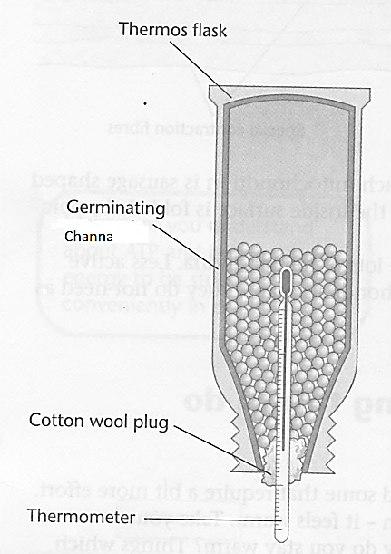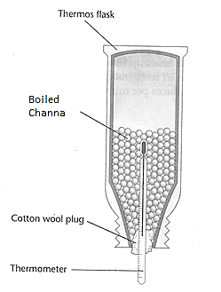
FLASK A – GERMINATING CHANNA FLASK B – BOILED CHANNA

DIAGRAM SHOWING THE SET UP OF APPARATUS TO INVESTIGATE AEROBIC RESPIRATION OF CHANNA.

METHOD:
- Label 2 flasks A and B.
- Weigh 50g each of germinating and boiled channa.
- Place the germinating channa in a Flask A and the boiled channa in Flask B.
- Secure the neck of the flask using cotton and tape with a thermometer inserted halfway in the flask.
- Invert the flasks and attach to the retort stand in a cool and shaded place.
- Record the temperature of each flask after five (5) minutes then again once every four (4) days.
Rewrite your method into past tense in the space below or on a separate page.
METHOD:
______________________________________________________________________________________________________________________________________________________________________________________________________________________________________________________________________________________________________________________________________________________________________________________________________________________________________________________________________________________________________________________________________________________________________________________________________________________________________________________________________________________________________________________________________________________________________________________________________________________________________________________________________________________________________________________________________________________________________________________________________________________________________________________________________________________________________________________________________________________________________________________________________________________________________________________________________________________________________________________________________________________________________________________________________________________________________________________________________________________________________________________________________________________________________________________________________________________
RESULTS: (Add a title to the table and collect your measurements, then plot a graph.)

Table showing _________________________________________________________________
Time (days) | Temperature of Flask A –  Germinating channa (°C) | Temperature of Flask B –  Boiled channa (°C)
0
1
2
3
4

Graph - Plot on a separate graph page or below.
Remember to put a TITLE and scale, label the axes with units of time (days) or temperature (°C).

DISCUSSION: (On a new page, using full sentences in paragraphs)
- Define aerobic respiration.
- Explain the importance of respiration in the body.
- Write the word and chemical equations for aerobic respiration (on separate lines each).

- List the conditions needed for germination. (Hint: water, oxygen and food in the seeds; sometimes darkness)
- Explain the function of the following in the experiment:- flask, cotton, and thermometer.

- Account for the changes in temperature (using the values in your result) in flask A and describe the shape of the curve on the graph.
- Account for the changes in temperature (using the values in your result) in flask B and describe the shape of the curve on the graph.

- Identify some sources of error or limitations as outlined below:
  - Thermometer may not have been secured properly in the cotton so the bulb may have not been in the centre of the channa to measure the correct temperature.
  - Readings of the thermometer may not have been at eye level.
  - Temperature reading collected at different times of the day may lead to unreliable data.
  - The masses of the channa were not correctly measured.
CONCLUSION: (Relate to your aim and findings/results.)
What did you find out in this lab about germinating channa undergoing respiration as opposed to dead channa?

MARKSCHEME – OBSERVING, RECORDING AND REPORTING SKILLS (ORR)
ORR CRITERIA |  | Mks
Observations | - Significant changes noted  - Original and final conditions compared  - Control noted OR diagram | 3
Recording  Tables/ Graph | - Title – above, in capitals - 1  - Column & row headings (with units) - 1  - Enclosed and neat -1  OR  - Title – at base, in capitals, underlined -1  - Both axes labelled with units - 1  - Accurate plots – 1 | 3
Reporting | - Format - ALL sections present – 1  - Aim in capital letters - 1  - Acceptable language and expression –  grammar – 1 and spelling – 1 | 4
TOTAL |  | 10
MARKSCHEME - ANALYSIS AND INTERPRETATION (AI)
Criteria (AI) | Marks
- Define aerobic respiration | 1
- Correct word and chemical equations | 2
- Functions of flask, cotton and thermometer | 3
- Explain results for Flask A vs Flask B | 2
- Identifying sources of error and limitations | 2
TOTAL | 10

