SEXUAL REPRODUCTION IN PLANTS
AIM: To observe and draw an insect pollinated flower – Pride of Barbados. Skill: DR
APPARATUS and MATERIALS:

- Magnifying glass
- Scalpel
- White tile
- Flowers from the Pride of Barbados plant – Caesaelpinia pulcherrima
- Tweezers/forceps
- Labelling and annotation guide

DIAGRAM:

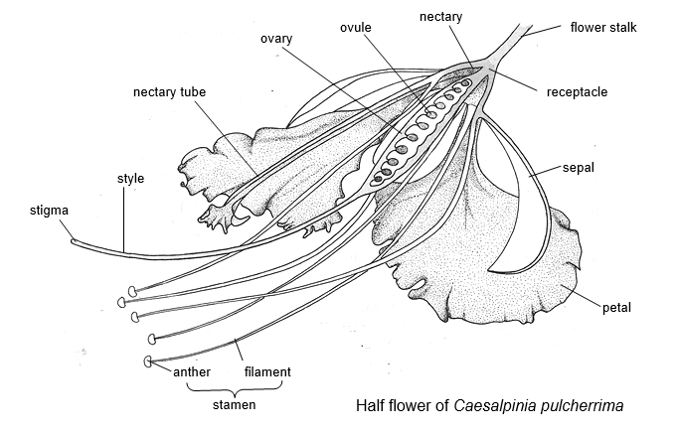
DIAGRAM SHOWING PARTS OF A FLOWER IN CROSS SECTION
(Source: http://www.biology-resources.com/plants-flowers-tropical.html)

METHOD:
- Obtain at least two mature (opened) Pride of Barbados flowers.
- Examine one of the flowers, pulling apart the pieces and identify the petals, sepals, stamens and carpels.
- Dissect the other flower in half using a knife, scalpel or razorblade.
- Make a large, labelled drawing of the half flower.
- Using the guide, add at least 3 annotations (functions of labelled parts)
- Calculate the magnification of your drawing and state it in the title of the drawing. Use the formula:
Magnification of drawing = size of drawing/ real size of flower

Rewrite your method into past tense in the space below or on a separate page.
METHOD:
_____________________________________________________________________________________________________________________________________________________________________________________________________________________________________________________________________________________________________________________________________________________________________________________________________________________________________________________________________________________________________________________________________________________________________________________________________________________________________________________________________________________________________________________________________________________________________________________________________________________________________________________________________________________________________________________________________________________________________________________________________________________________________________________________________________________________________________________________________________________________________________________________________________________________________________________________________________________________________________________________________________
RESULTS: (Make a large labelled, annotated drawing of the Pride of Barbados flower cut into cross section – the half flower.)

CALCULATION OF MAGNIFICATION:
Magnification of drawing = size of drawing / size of flower
= ____________/_____________
= _X_____________
TITLE: DRAWING SHOWING A __________________________________________ FLOWER IN _____________________VIEW/SECTION (MAG X_____)
DISCUSSION: (On a new page, using full sentences in paragraphs)
- What is the main function of a flower?
- Does this flower have male and female parts on same flower?
- Name the flower structures which protects the young flower bud.
- Is this flower likely to be insect pollinated? Give at least 2 reasons for your answer. (Hint: flower colours, location of stamen – anther and filament)

CONCLUSION: (Relate to your aim and findings/results.)
What did you find out in this lab about Pride of Barbados flowers?

Flower structure (tropical) 1 - Caesalpinia pulcherrima
A flower is a reproductive structure of a plant. The Caesalpinia, illustrated below, shows the main features of a flower but different species have different arrangements of the parts.
The conspicuous part of many flowers consists of the petals which are white or brightly coloured. The petals serve to attract insects which help pollinate the flower.
The sepals are usually small and green. They enclose the flower when it is in the bud.
The male part of the flower consists of stamens. The stalk of the stamen is the filament. At the end of the filament is an anther which contains pollen grains. The pollen grains contain the male reproductive cells (gametes).
The female part of the flower consists of carpels. Each carpel consists of an ovary which contains an ovule which is the female gamete. Extending from the ovary is a style which ends in a stigma which receives the pollen from another flower.
The ovules when fertilized will become seeds, while the whole ovary will be the fruit.
The receptacle is the expanded end of the flower stalk. All the parts of the flower are attached to the receptacle.
Nectaries are swellings, often at the base of the ovary or on the receptacle, which produce a sugary solution called nectar. Insects visit the flower and drink or collect this nectar.

The half-flower
A drawing of a half-flower is a convenient method of representing flower structure. The flower is cut in halves with a razor blade. The outline of the cut surface is drawn, and the structures visible behind these are filled in.

