HEAT TRANSFER IN SOLIDS AND LIQUIDS
AIM: To investigate how heat is transferred through a solid and a liquid. Skill: ORR
APPARATUS and MATERIALS:

- Vaseline or wax
- Retort stand
- Metal rod (BRC)
- ruler
- paperclips (5)
- Bunsen burner
- tripod
- Stopclock
- Coloured crystals
- Straw/funnel
- Foil (30cm long)
- Large beaker of cold water
- matches

DIAGRAM:
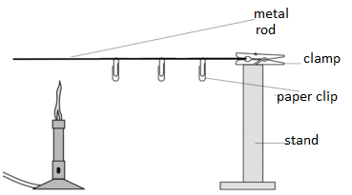
a) Possible set-up of apparatus to investigate heat transfer in a solid.
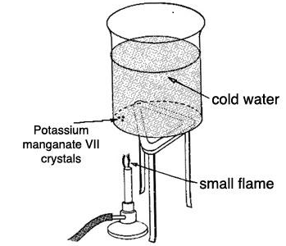
b) Set up of apparatus to investigate heat transfer in a liquid

METHOD:
a) HEAT TRANSFER THROUGH A SOLID
- The foil was placed on the table and then the candle was lit.
- Three drops of wax were carefully dropped at 5cm intervals along a metal rod.
- Three paperclips were inserted into the wax before it hardened.
- The rod was attached to a retort stand and the free end was heated with a Bunsen burner.
- Observations and the time taken for each paperclip to fall off the rod was recorded in a table. A graph was drawn.
b) HEAT TRANSFER THROUGH A LIQUID
- Coloured crystals were added to the base of a beaker of cold water using a straw.
- The beaker was placed on a tripod stand and heated just below the crystals.
- The colour and movement of the water was observed and recorded in a diagram.
RESULTS:
a) Heat transfer through a solid
Table showing time taken for paperclips to fall off a metal rod.
Distance from end of rod/ heat source | Paper clip # | Time taken (mins)
5 cm | 1
10 cm | 2
15 cm | 3
Remember 1 minute has 60 seconds. So 15 s = 0.25min and 30s =0.5min
Graph showing rate of time taken for paper clips to fall off a metal rod. – Plot on a separate graph page. Remember to put TITLE, scale, label the axes including the units of time or distance.

b) Heat transfer through a liquid
Annotated diagram showing the movement of coloured liquid in water as it was being heated up. Remember annotations should explain the observations.
Condition before heating | Conditions after heating

DISCUSSION:
a) Heat transfer through a solid:
- Identify the manipulated variable ________________________, and responding variable ___________________________. What could have been a suitable control? (Hint – keeping distance constant at say 5cm and repeating the experiment)
- Why did the paperclips fall off the rod when it was heated?
- What is this transfer of heat called?
- This shows that metals are useful in ???? (Hint cooking – making pans, etc)
- Do all metals heat up and transfer heat at the same rate? Why/ why not?
b) Heat transfer through a liquid:
- How was the heat from the Bunsen burner transferred?
- How was the heat transferred throughout the body of water?
- Why did the coloured liquid rise and move in circular directions?
- How can convection be useful to us?

CONCLUSION:
How was the heat transferred through the solid? – How could you tell?
How was the heat transferred through the liquid? – How could you tell?

MARKSCHEME – OBSERVING, RECORDING AND REPORTING SKILLS (ORR)
Criteria |  | Mark
Observing | Correct times for paperclip drop noted | 1
 | Annotations  - direction of movement of water;  - hot and colder parts of the water | 1  1
Recording | Title for table | 1
 | Title for graph | 1
 | Correctly plotted graph | 1
 | Correctly labelled axes with units | 1
Reporting | Correct format of lab – all parts, in order | 1
 | Conclusion is clearly stated | 1
 | Conclusion links results with the aim | 1
TOTAL |  | 10

