HOW DOES SWEATING COOL US DOWN?
AIM: To investigate how sweating cools down the body . Skill: MM
APPARATUS and MATERIALS:

- Hot water
- Tap water
- Scale balance
- Cotton wool or tissue paper
- Tape
- 2 Bungs with thermometers
- 2 conical flasks
- Measuring cylinder
- Stopclock
- Labels

DIAGRAM:
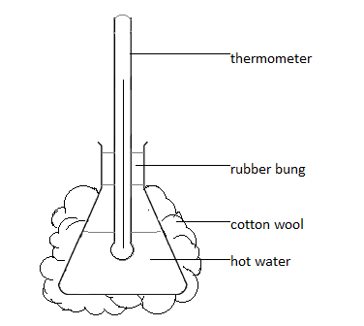
Drawing showing set up of apparatus - control
b) Drawing showing set up of apparatus - sweating

METHOD:
- The outside of two conical flasks were covered with dry tissue paper held with tape.
- 200cm³ of hot water was measured with a measuring cylinder and carefully placed in each conical flask.
- The bung with thermometer was attached to each flask. When the temperature of both had fallen to 60ºC, the time was taken as 0 minutes.
- One flask was thoroughly moistened with tap water and the other left dry
- The temperature of the water in each flask was recorded in the table every minute for 10 mintues.
- A cooling curve for each flask was plotted.

RESULTS:
Table showing cooling of dry and moist covered conical flasks over 10 minutes
Time (mins) | Temperature of
 | Dry flask (⁰C) | Moist flask (⁰C)
0 | 60 | 60
1
2
3
4
5
6
7
8
9
10

Title of graph: Graph showing ____________________________________________________.
Scale: X axis: ____________________
Y axis:____________________
DISCUSSION:
In this experiment, the conical flasks of hot water represents (models) our ___________. The moist tissue paper represents_______________________. When sweat evaporates, it takes some of the body heat with it.
The manipulated variable was ___________________________________.
The responding variable was ____________________________________.
The following were kept constant _________________________________________.
Other key ideas to explain your results:
- The air in dry tissue paper cannot move
- Wetting the tissue paper removes the air
- Water is a much better conductor of heat than air
- The hot water in the flask touches the glass, which touches the tissue paper
- Particles that are touching can transfer heat by conduction
- Particles need to move to transfer heat by convection
CONCLUSION: How does sweating cool us down? How did you know.
According to the results of the experiment, sweating cools down the body by ________
________________________________________________________________________
MARKSCHEME – MANIPULATION AND MEASUREMENT (MM)
Criteria |  | Marks
Use of thermometer
1 | Immersion of bulb completely in liquid | 1
2 | Stirring liquid to ensure even distribution of heat | -
3 | Lack of contact of bulb with container | 1
4 | Immersion time adequate for equilibrium | 1
5 | Reading taken while bulb is immersed | -
6 | Reading taken at eye level | 1
7 | Careful handling and temporary storage to prevent breakage | 1
8 | Accurate interpretation of scale | 1
Use of measuring cylinder
9 | Cylinder is placed on a flat, horizontal surface | 1
10 | Readings are taken at eye level | 1
11 | All liquid is completely poured out of the cylinder | 1
12 | The cylinder is washed after use and allowed to drain | 1
TOTAL |  | 10

