LENGTH MEASUREMENTS – MICROSCOPE WORK – CAPE BIOLOGY
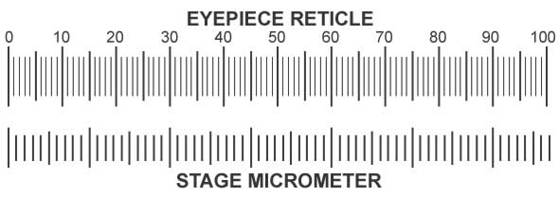
It is always useful to know the size of a specimen and quite often e.g. with protozoans, size is an important diagnostic feature.
Measurements of microscopic objects is a relatively simple process and uses two piece of apparatus
- Ocular micrometer a.k.a. eyepiece graticule
- Stage micrometer
This ocular (eyepiece) micrometer is a glass disc with a scale. The divisions of the scale are of equal size but the intrinsic value of the divisions differs with the objective lens used. Hence this scale has to be calibrated for each objective i.e. x4, x10 and x40. This disc is inserted into the eyepiece of the microscope and usually is left there permanently.
The stage micrometer is used to calibrate the eyepiece micrometer and in essence it is a conventional slide having a scale graduated in units of 1/10mm. The stage micrometer can be exactly 1cm long or 1mm long.
The eyepiece micrometer is calibrated using the following procedure
- Remove the eyepiece from the microscope
  - Unscrew the upper eyepiece lens
  - Insert the ocular micrometer – scale upwards.
  - Screw the eyepiece together again and replace into the tube.
- Place the stage micrometer on the microscope stage and using the lowest power objective (x4) focus on the slide.
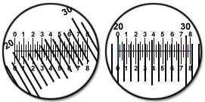
- Once you have focused sharply, both scales should be clearly defined. Turn the eyepiece until the two scales lie parallel to each other.

- Adjust the stage micrometer so that two lines on its scale coincide exactly with two lines on the eyepiece graticule.

Determine the number of eyepiece divisions which correspond to a certain distance on the stage micrometer.
For example, at x4 objective lens:
4 eyepiece divisions = 1 stage division
But we know that 1 stage division = 100µm (or 0.1mm)
Therefore, 1 eyepiece division = ¼ stage divisions
= ¼ (100)µm
= 2.5µm (or 0.0025mm)

- The above calculation applies only to the x4 objective lens which was used. The entire procedure must be repeated for the other objectives. These values must be recorded for future use.
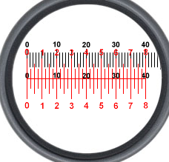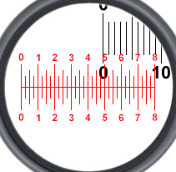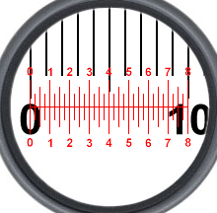

- Subsequently when measuring, only the eyepiece graticule is used. Now it is only necessary to multiply the number of eyepiece divisions recorded by the micrometer value (for that particular objective lens). You will now know the actual size of the object being viewed.
- You can now determine the real size of any object you are observing.
- You can also now calculate the magnification of your drawings.

Remember :
$$magnification of drawing=\frac{size of drawing }{real size of object}$$

