IS OXYGEN NEEDED FOR GERMINATION SKILLS: ORR/MM
AIM: To investigate if oxygen is needed for germination
INTRODUCTION: Germination is the process whereby a seed begins to form new life; usually seen as the radicle emerging through the seed coat. In general, the conditions needed for germination are water and warm temperatures; some seeds also require light too. This lab will investigate if oxygen is needed also. A seed contains a store of food in its cotyledons. These substances, once broken down and digested by enzymes are converted to soluble substances to grow the embryo. In order to breakdown substances, oxygen is required for aerobic respiration to generate energy. Water that is imbibed through the microypyle is used to activate these enzymes. As growth of the new embryo – radicle and plumule occurs, the cotyledons begin to shrivel and decrease in mass.

APPARATUS AND MATERIALS:

- 6-8 mung bean seeds
- Cotton wool
- Thread
- scissors
- 1 spatula
- A 50cm³ measuring cylinder
- Two conical flasks with bungs
- Sodium hydroxide (NaOH) solution
- Pyrogallic acid

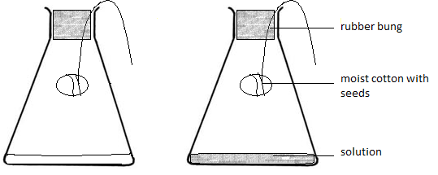
DIAGRAM OF THE SET UP OF APPRATUS
Note: when pyrogallic acid is mixed with sodium hydroxide, it absorbs oxygen and carbon dioxide.
METHOD:
- Label two conical flasks A and B, measure 25cm³ sodium hydroxide solution and place into each.
- Moisten two pieces of cotton wool and roll an insert 3 – 4 mung beans in each. Ensure they cannot fall out.
- Tie each piece of cotton wool to one of the bungs so that the cotton will hang clear of the solution in the flask.
- Add 2 spatulas full of pyrogallic acid to just one of the conical flasks - A. Cover immediately, then swirl that flask to mix. It will turn dark brown or black.
- Take one piece of cotton wool with the beans and suspend in flask A. Cover immediately. Do not let the cotton touch the sides of the flask or the solution in the flask. Do the same with B.
- Leave both flasks in a warm place for 48 hours.
- At the end of two days, note how many seeds germinated in each flasks in an appropriate table.

RESULTS:
Table showing number of seeds germinated in each flask
Time | Flask A – pyrogallic acid and sodium hydroxide | Flask B – sodium hydroxide
Day 0
Day 2

DISCUSSION:
- What is germination? What are the conditions needed for germination?
- According to your results, is oxygen needed for germination? Why? – What specific cellular processes requires it.
- What was the function of NaOH? (absorb CO₂and create an alkaline environment for pyrogallic acid)
- What was the function of pyrogallic acid? (an alkaline solution to absorb oxygen from the air).
- What are some precautions you took while doing the lab and why?
  - carefully adding acid
  - Closing the flasks quickly so that atmospheric oxygen and carbon dioxide does not react with the internal air?
  - placing in a warm place
  - ensuring no acid got on the cotton
- What are some limitations?
  - Seeds did not germinate because they were old
  - The temperature was not warm enough
  - Contaminating the cotton with the acid.
CONCLUSION: answer the following.
Is oxygen needed for germination? What does your results show?

