WHAT IS SCIENCE?

Science uses evidence to learn about the natural world; it is a body of knowledge. Science begins with observations – often taking data on what you see, hear or smell. Data is the information gathered from observations and may be either quantitative data = numbers or qualitative data = descriptive.
Facts, problems, or situations which you may not understand require more information gathering (research) or you can ask another scientist. Sometimes you may want to find out yourself by planning and designing an experiment. The steps involved is known as the Scientific Method.
The Scientific Method is an organised and systematized effort to gain knowledge that uses observation and experimentation to describe and explain nature or natural phenomenon.
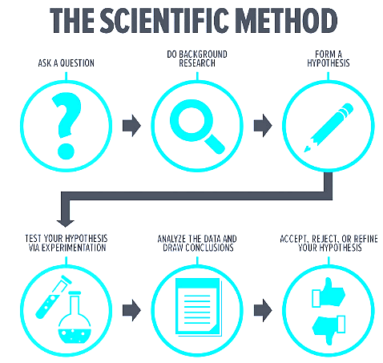
- Inference – a logical interpretation based on prior knowledge or experience (Ex. You see a window broken and a baseball on the floor next to the shattered glass. You can -infer- that a baseball broke your window)
- Hypothesis – a proposed scientific explanation. This statement is testable and can be confirmed with experimentation or further observation.
- Prediction – An if-then statement that shows what you expect to see as a result of an experiment or observation (Ex. If fertilizer makes a plant grow faster, then seedlings planted with fertilizer will be taller than the ones planted without fertilizer)

Your plan and design lab may follow the steps in the Scientific method. The layout or format for a plan and design lab is a little different from what you are accustomed to. See lab guide for PD #1.

WHAT IS A HYPOTHESIS?

- A hypothesis is a tentative generalized statement – it gives a suggested reason for something you observed and you can test it.
  - Tentative – because you do not know yet if your suggestion makes sense.
  - Generalization – because if it is accurate you can use it to explain similar observations.
  - Testable – because by making more observations, under controlled conditions you can find out whether you were right or wrong.
- A good hypothesis has four basic characteristics:
  - One condition or variable only is considered
  - It can be tested
  - Relates directly to the observation made
  - Makes common sense.
Example:
Observation: A certain species of fly emerges from the soil into the air when it rains/ Rainflies are seen swarming after rain.
Step 1. – List out the possible reasons for this
- The flies prefer wet conditions
- Their nests become flooded when it rains
- There is more food around at that time
- Rain acts as a signal for them to come out and mate.
Step 2. – Select the best explanation for your observations by:
- Compare your observations with what your know
- Put more than one observation together
- Ask – what effect does rain have on the surroundings? How is it different before and after rain? Do other animals you know behave this way?
Step 3. – Write down your explanation so that it can be tested.
It is testable if you can predict what will happen when the explanation is true. You can tell when the flies will come out OR you can create the right conditions to make them move.

Examples of acceptable hypotheses:
- Rain flies prefer wet conditions.
- Flies move away from flooded areas.
- Flies swarm when their food is available.
- Flies mate after rain falls.
Not so good hypotheses
- Flies come out after the rain because they prefer when it is wet or dark.
- Flies come out of their nests to look for food when it is raining.
- Flies come out after the rain because their predators cannot see them clearly.
- Flies come out after rain to get water.

DESIGNING AN EXPERIMENT – CONSIDERATIONS

- Observation/ problem statement
  - List out possible reasons - ID contributing variables – all the factors/ conditions that affect the process
  - Select best explanation – choose one factor/condition to investigate (manipulate)
  - Make the explanation testable -
- State hypothesis – Rain-flies prefer wet conditions.
- Write down your aim – To find out whether rain-flies prefer wet or dry conditions.

- Think carefully about what you want to find out – to plan the method.
  - Measurements - What measurements to make? How? (counting flies, humidity, rainfall)
  - Time - How long will the investigation take, how often to measure?
  - Apparatus - what equipment/ lab apparatus is needed? How to use them?
  - Treatment/ Trials - Should there be repeats or trials? How many treatments to make? Is there a control set-up? Use real specimens or models? Investigate in the field or in the lab?
  - Precautions - Identify measure to take, Are there any safety considerations?
- State variables – manipulated, responding, constant.

- Decide what is the best way to collect data/ Outline Expected Results
  - Draw up a blank table to collect systematic data e.g.

    - count the number of flies seen at specific times
    - Measure humidity at those times
    - Keep a record of how much rain falls
    - Keep records for several different nests.

Days | Number of flies |  |  | Humidity (%) | Rainfall (mm)
 | Site 1 | Site 2 | Site 3 | Site 1, etc. | Site 1, etc.
1
3
5 …
15

- State any limitations of the method. Anticipate any factors which you cannot control.

- Explanation of expected results - How to analyse the data – what patterns to look for and how to interpret and draw conclusions.

FORMAT OF A PD LAB

CSEC BIOLOGY – SAMPLE PD – FROM TEXTBOOK
Taken from Longman Biology for CSEC:
Observation:
Vonnie observed that her mother places slices of fresh green pawpaw on meat for about half an hour before cooking it.
Vonnie’s Scientific Question:
Why does my mother place the green pawpaw on the meat?
Developing the hypothesis: this involves listing the variables which may affect what goes on with the pawpaw and the meat. Vonnie reckons that one variable in particular may be important.

Variables:
1. Acidic substances and
2. Enzymes are present in pawpaw that may break down proteins in meat.

Hypothesis: Pawpaw contains and enzyme which breaks down protein in meat
Aim: To test green pawpaw slices to see if they contain enzymes which break down protein.
Apparatus and materials:
- A source of protein e.g. egg white cubes coloured red with dye/ cubes of hotdog
- Fresh green pawpaw juice, boiled green pawpaw juice, commercial trypsin solution, distilled water.
- Measuring cylinder, 4 test-tubes in a rack, ruler, scalpel, mortar, pestle, filter paper, hand lens, 4 Petri dishes.
Method: (written in the active voice, present tense)
- Cut 16 cubes of hot dog or egg white, with sides of 1cm
- Crush slides of pawpaw in a mortar using a pestle, then filter
- Label four test tubes A, B, C and D.
- Measure 5ml of distilled water in the test tube labelled A. (this is the control!)
- Measure 5ml of fresh pawpaw juice in the test tube labelled B.
- Measure 5ml of boiled pawpaw juice in the test tube labelled C.
- Measure 5ml of trypsin solution in the test tube labelled D.
- Place four cubes of hot dog or egg white into each test tube
- Leave for 30 minutes.
- Pour each of the test tubes’ contents into separate Petri dishes.
- Using a hand lens, observe the consistency of the hot dog or egg white cubes.
- Tabulate the results.

Variables:
Manipulated – type of solution;
Responding – texture of the meat;
Constant – same volume of solution in each test tube; meat cubes left for 30 minutes each; same size cubes; same number of cubes; test tubes same size, shape and materials.
Expected Results:
Table showing expected results of a test to see if pawpaw contain enzymes that breakdown protein.
Test tube | Contents | Expected Observations
A | Distilled water | Protein should remain firm and in one piece.
B | Fresh pawpaw juice | Protein should be soft with small pieces broken off the cube.
C | Boiled pawpaw juice | Should be firm in one piece
D | Trypsin | Should be soft with small pieces broken off the cube.

Interpretation of Expected Results:
- Fresh green pawpaw slices contain enzymes which digest protein.
- This causes the meat to become soft.
- The meat in test tubes with fresh green pawpaw juice and the enzyme trypsin would become soft.
- If the pawpaw is cooked, the enzymes would be denatured and would not work.
Limitations:
In this activity the pH in some tubes (B and D) may not remain constant. The temperature may not have remained constant throughout the experiment.
Sample mark scheme for Plan and Design Labs (PD)
CRITERIA FOR PD |  | Mark
Hypothesis | -stated (plausible)(1)  -testable | 2
Aim | -related to hypothesis, specific  And related to method | 1
Apparatus and Materials | List of appropriate apparatus & materials to be used | 1
Procedure | -logical steps/ sequences (1)  -repetitive of steps for accuracy (1) | 2
Control | Reasonable | 1
Expected results & Interpretation | Must be clearly stated in words | 1
Limitations | -should include shortcomings of the design which may become a source of error | 1
Suitable format | Suitable for PD activity | 1
 | TOTAL | 10

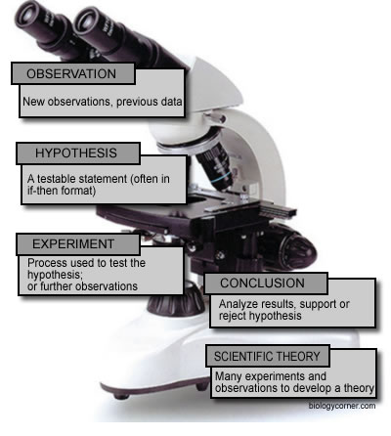
THE SCIENTIFIC METHOD IN ACTION

Example 1 - Crickets
Suppose you observed that a cricket outside your window seems to be chirping every night, but some nights it chirps faster than others. A friend of yours told you once that you can use the sound of a cricket chirp to tell the temperature. Curious, you decide to design an experiment. First you must create a hypothesis; here are some examples of possible hypotheses:
- The frequency of cricket chirps will change as the temperature changes.
- As the temperature decreases, a cricket will chirp fewer times.
Either hypothesis will work, the important thing is that you can -test- the hypothesis by doing an experiment which will confirm or deny the statement.
To set up the experiment, you go out to your yard and capture a few crickets. You bring them inside and place them in a container. But wait, if you have a bunch of crickets together, what if they chirp based on how many crickets there are nearby. The goal in designing an experiment is to eliminate all the variables except the one you are testing. This means all your cricket subject must be housed in the same environment (same lighting, same food, same water..etc). Okay, so you get that set up and take the temperature of your room. Now you must wait for the crickets to start chirping. You count how many times the cricket chirps for a 5 minute period.
Now you have to compare that number with the chirps that occur at different temperatures. You may use a heating pad, or ice or any other way to lower or raise their temperature. You would then take data for 5 minutes at the new temperature.
In your experiment, the MANIPULATED VARIABLE is the thing you changed – the temperature. The RESPONDING VARIABLE is what you are measuring that happens as a result of that change - the number of chirps.
The CONTROL GROUP isn’t obvious in this case – but you can consider your original (room temperature) data as your control, and the other temperatures your experimental data.
After you have taken data, you can then draw a conclusion about whether your hypothesis is accepted (correct) or denied (incorrect).

Example 2 - The Strange Case of Beri Beri
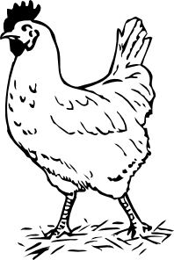
In 1887 a strange nerve disease attacked the people in the Dutch East Indies. The disease was beriberi. Symptoms of the disease included weakness and loss of appetite, victims often died of heart failure. Scientists thought the disease might be caused by bacteria. They injected chickens with bacteria from the blood of patients with beriberi. The injected chickens became sick. However, so did a group of chickens that were not injected with bacteria.
One of the scientists, Dr. Eijkman, noticed something. Before the experiment, all the chickens had eaten whole-grain rice, but during the experiment, the chickens were fed polished rice. Dr. Eijkman researched this interesting case and found that polished rice lacked thiamine, a vitamin necessary for good health.
- State the Problem
- What was the hypothesis?
- How was the hypothesis tested?
- Should the hypothesis be supported or rejected based on the experiment?
- What should be the new hypothesis and how would you test it?

Example 3 - How Penicillin Was Discovered
In 1928, Sir Alexander Fleming was studying Staphylococcus bacteria growing in culture dishes. He noticed that a mold called Penicillium was also growing in some of the dishes. A clear area existed around the mold because all the bacteria that had grown in this area had died. In the culture dishes without the mold, no clear areas were present.
Fleming hypothesized that the mold must be producing a chemical that killed the bacteria. He decided to isolate this substance and test it to see if it would kill bacteria. Fleming transferred the mold to a nutrient broth solution. This solution contained all the materials the mold needed to grow. After the mold grew, he removed it from the nutrient broth. Fleming then added the nutrient broth in which the mold had grown to a culture of bacteria. He observed that the bacteria died which was later used to develop antibiotics used to treat a variety of diseases.
- Identify the problem.
- What was Fleming's hypothesis?
- How was the hypothesis tested?
- Should the hypothesis be supported or rejected based on the experiment?
- This experiment lead to the development of what major medical advancement

