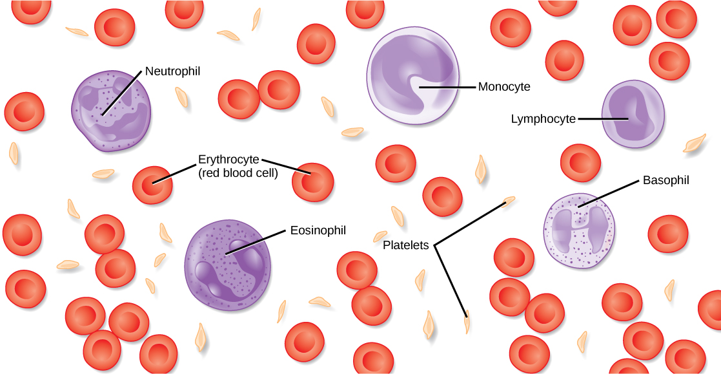
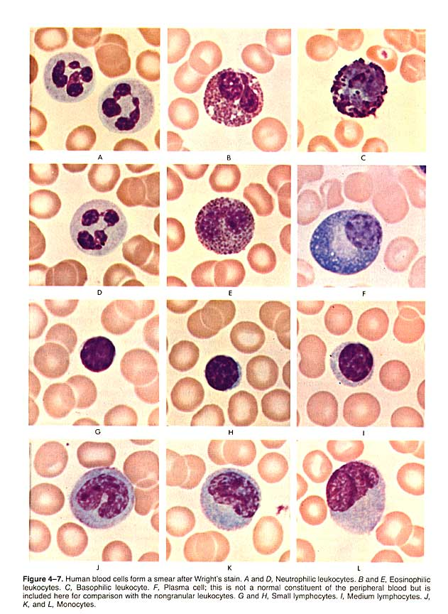
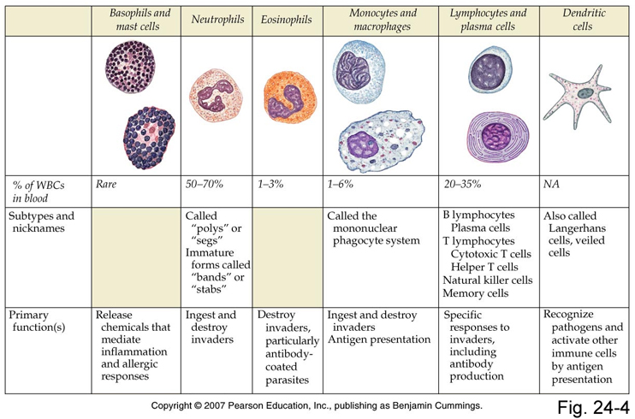

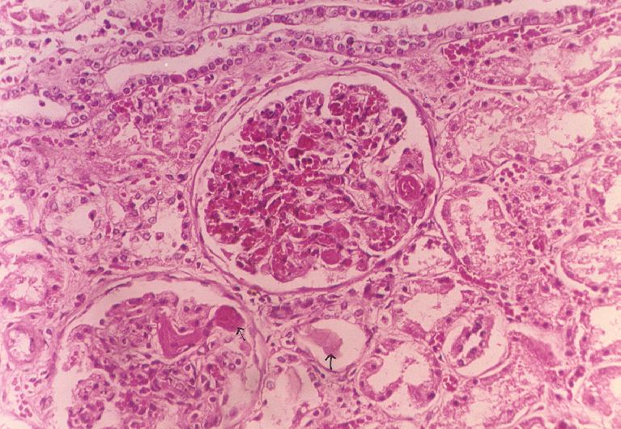 206 – www.ym.edu.tw
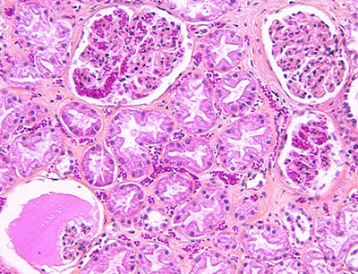
Athena’s Heirs: The History of Medic… - www.museevirtuel-virtualmuseum.ca
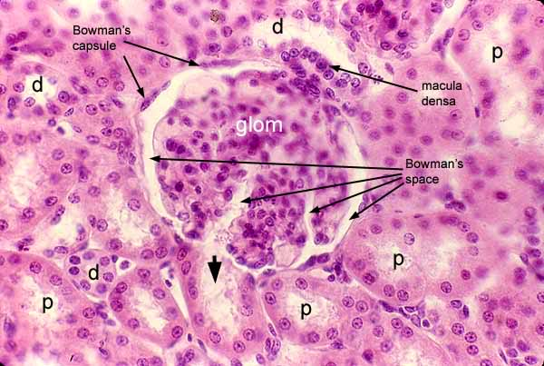
Anatomyforme: 2008 – anatomyforme.blogspot.com
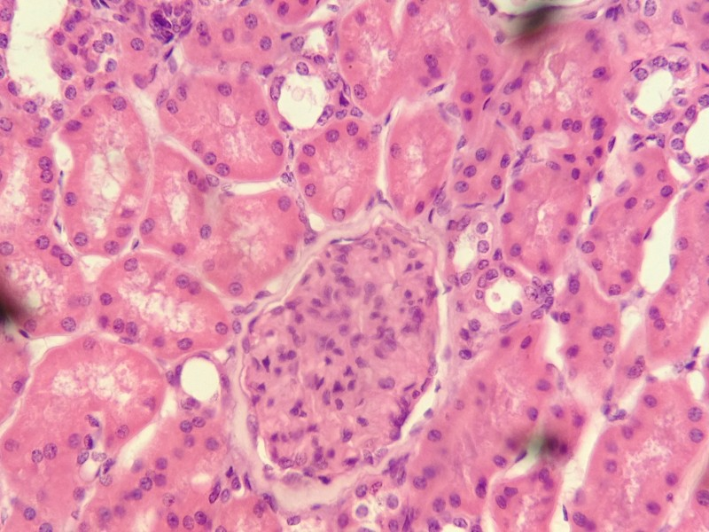
Proximal and distal convoluted – histolotyolm.umwblogs.org
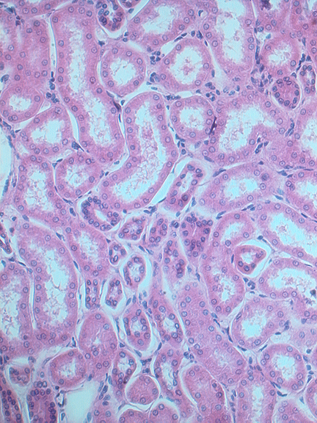
Urinary system – www.iupui.edu
http://www.biologyofhumanaging.com/slides/kidney07.htm

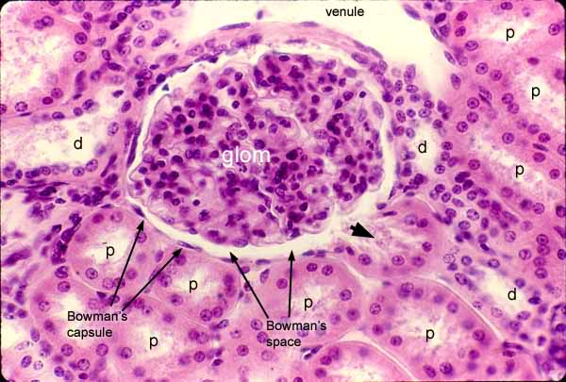
Anatomyforme.blogspot.com

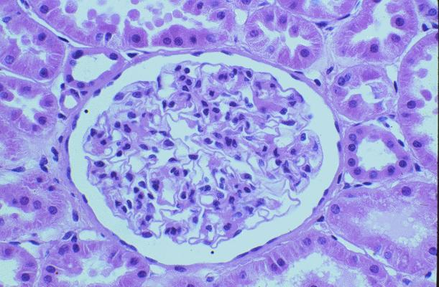
www.studyblue.com
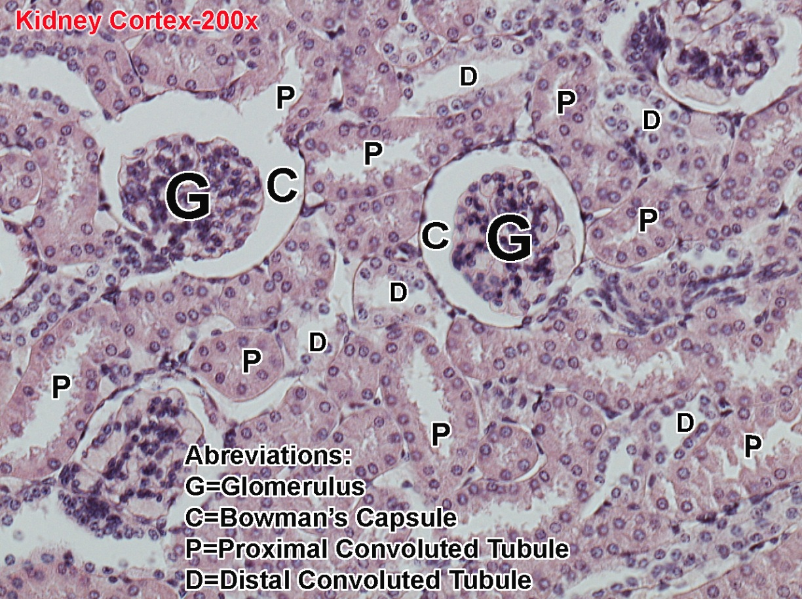
Microscope pictures – www.montgomerycollege.edu

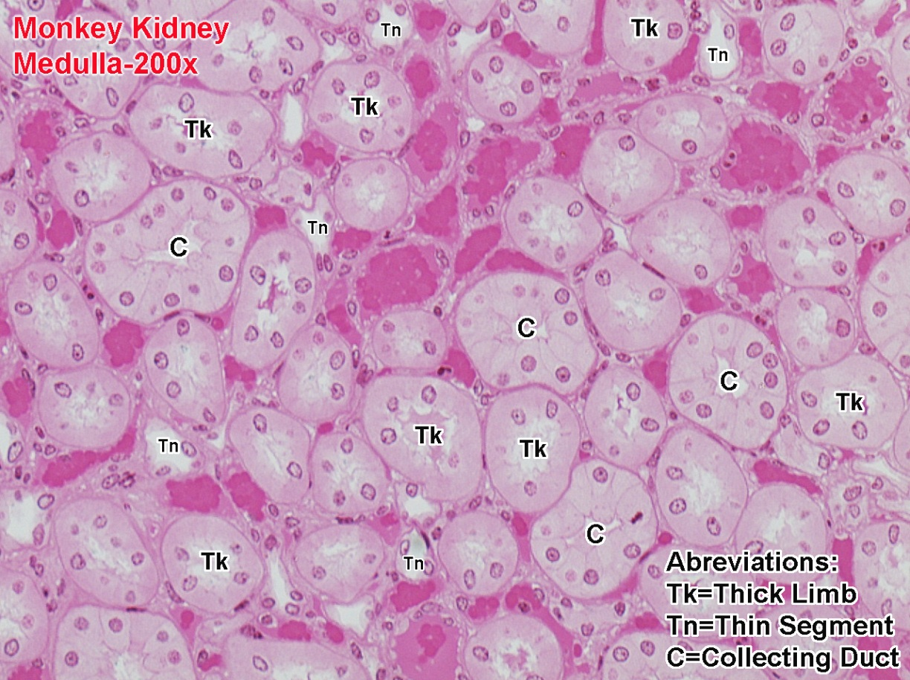

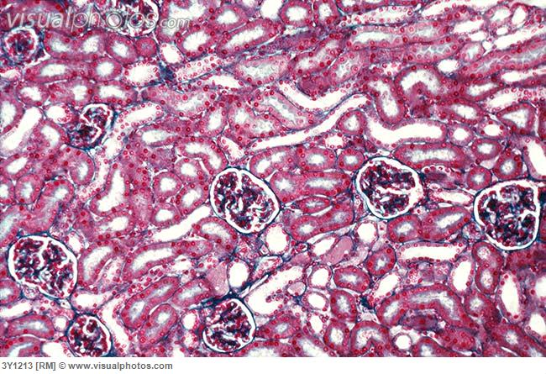
LM of renal cortex [3Y1213]

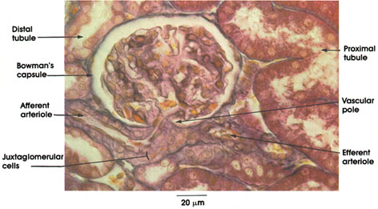
Anatomy atlases: atlas of microscopic…-www.anatomyatlases.org

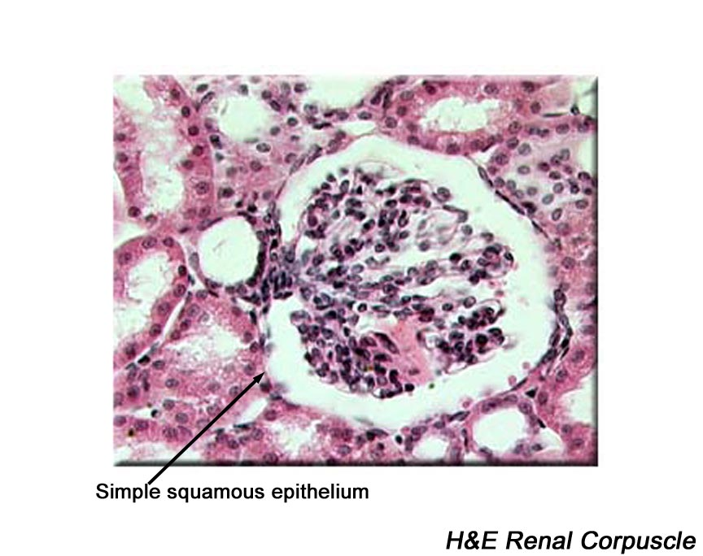
Urinary system – www.courses.psu.edu

