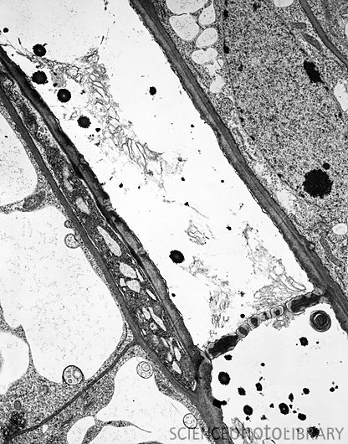

Phloem sieve tube, TEM
C009/5852 Rights Managed
Credit: BIOPHOTO ASSOCIATES/SCIENCE PHOTO LIBRARY
Caption: Phloem sieve tube. Transmission electron micrograph (TEM) of a longitudinal section through the stem of a thale cress (Arabidopsis thaliana) plant. Phloem sieve tubes are seen diagonally across centre. A sieve plate between the cells is seen towards bottom right. The phloem transports carbohydrates and hormones around with plant.
Release details: Model and property releases are not available

Longitudinal Section Through the Phloem of Cheiranthus cheiri (Brassicaceae)

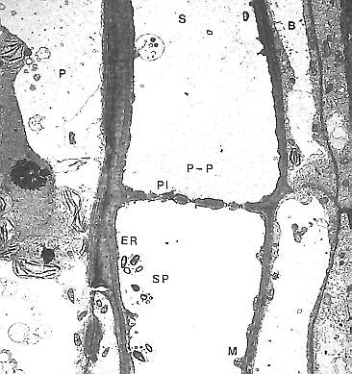
Sieve tube without (S) and companion cells with nuclei (B). They are bordered by a parenchyma cell (P). The sieve tube contains sieve tube plastids (SP of the S-Type), mitochondria (M), endoplasmatic reticulum (ER) and P-proteins (P-P). The sieve plate (P1) is perforated by pores. (H.-D. BEHNKE, 1981)

© Peter v. Sengbusch - Impressum

